MZIMBA NORTH TERM 1 FORM 4
GEOGRAPHY PAPER 1 MARKING KEY
SECTION A (75 Marks)

  - 551707 (plus 1 or minus 1) (2 marks)
b. (i) No (1 mark)
(ii) There is a hill/highland between these two places. (2 marks)

c. 3.2km to the nearest km its 3km (2marks)

d. Full squares = 10
Half squares = 13
Total full squares 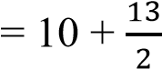
= 10 + 6.5
= 16.5
Total area = 16.5 × 1km²
= 16.5 km²
(5 marks)
e. - Cultivation/farming
    - Settlement
- Institutional (Explain any two-4 marks)

f. -using contour lines
-trigonometric station (2 marks)

g. G = VI / HE (1 mark)
VI = (2600ft - 1700 ft) =900ft (1 mark)
900ft = more
900ft / 50ft x 1m = 18m (1 mark)
HE = 4.1km (1 mark)
1km= 1000m
4.1 km = more
4.1km / 1km x 1000m = 4100m (1 mark)
= 18m / 4100m (1 mark)
= 1/227.777
= 1/277.8 (to 1 dp) (1 mark)

- a. (i) divergent (1 mark)
(ii) -Volcanic mountain
- Oceanic ridge
- Volcanic island
- Rift valley
- block mountains
- Earthquakes
(Any three points, 1 mark each)
(iii) - Mountains act as a barrier to communication and transportation.
- Leeward sides of mountains receive little or no rain
- They are sources of earthquakes and volcanicity which kill people and cause injury. (3marks)
b. (i) These rocks are formed when water evaporates ⁽¹⁾ from salt precipitates, leaving behind layers of salt ⁽¹⁾ which are compacted into rocks. ⁽¹⁾ (3 marks)
(ii) - Borax
- Potash
- Gypsum
- Nitrates
- Rock salt (halite)
(Any two points, 2 marks)

c. (i) bird’s foot or digitate delta (1 mark)
(ii)-the delta extends into the ocean
-the delta has fewer distributaries
-composed of fine-grained sediments
-shaped like the foot of a bird
-formed when river load is less dense that the ocean waters
(Any three points, 3 marks)
(iii) -contain rich mineral deposits (promotes mining industry)
-provide vast lands for human settlements, industrialization and urbanization
-ideal topography (gentle) for transport development (railways etc)
-promote the fishing industry (presence of more rivers)
-provide very fertile soils ideal for farming
(Explain any two points, 4 marks)

d. (i) -planting more drought tolerant food crops like cassava, millet, sorghum sweet
potatoes can be reintroduced into the farming systems.
-Promoting irrigated agriculture by developing irrigation schemes along river basins
-Addressing land degradation by building soil and stone bunds, creating grass strips and contour
leveling as well as incorporating trees or hedgerows.
-Creating functional linkages with development partners for technology enterprise initiatives.
-Diversifying rural economies, e.g. through value addition to agricultural products and financial
support for apiculture (bee keeping) with the aim of reducing reliance on climate-sensitive
agricultural practices.
-Reducing reliance on centralized food system where commodity production is concentrated in a
few locations that may be vulnerable to climate disruptions such as storm damage, pest
outbreaks, etc.
-Switching to new crops, seeds or agricultural practices can moderate the impacts on agriculture of changes in temperature and water availability.
-Improving weather and flood forecasting and communications can assist evacuation, relief and
rehabilitation
(4 marks, 2 for any one point explained)
(ii) -Creating awareness on the dangers of air pollution.
-Using alternative sources of energy that do not pollute the air.
-Enacting and enforcing laws to protect the environment.
-Establishing measures and policies in factories in order to control the level of air pollution.
-Dispersing and diluting pollutants in the upper layers of the atmosphere with the aim of
reducing concentration at the lower levels.
-Preventing occurrence of bushfires.
-Carrying out afforestation and re-afforestation practices.
-Monitoring levels of air pollution regularly.
-Using clean energy at home and in industries
(2 marks, 1 for any one point mentioned)
- a. (i) Draw a globe with main air pressure belts in the southern hemisphere.
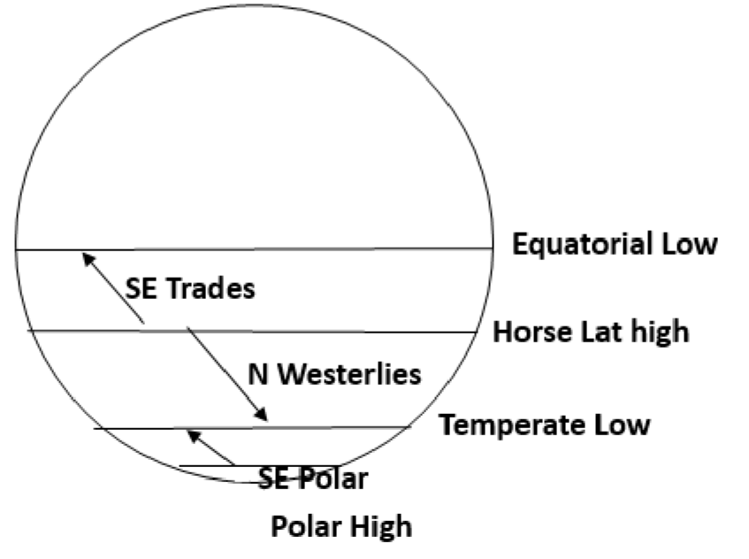
(2 marks for the globe and any two main pressure belts)
(ii) (2 marks for any two prevailing winds)

b. (i) -Guinea, Mali, Ghana, Togo, Senegal, Burkina Faso, Ivory Coast, Sierra Leone
(Any 2 points, 1 mark each)
(ii) 1. Chinook.
(1 mark)
2. -It is warm
-It is dry
-Common in spring and in winter
-Blows from western side and descend on the eastern side of the Rocky Mountains.
(Any 2 points 1 mark each)
3. -Melt ice hence named Ice Eater
-Increases the risk of fire in the region they blow
-They increase temperature by 19 degrees Celsius within 15 minutes.
(Any 3 points 2 marks each)
c. (i)
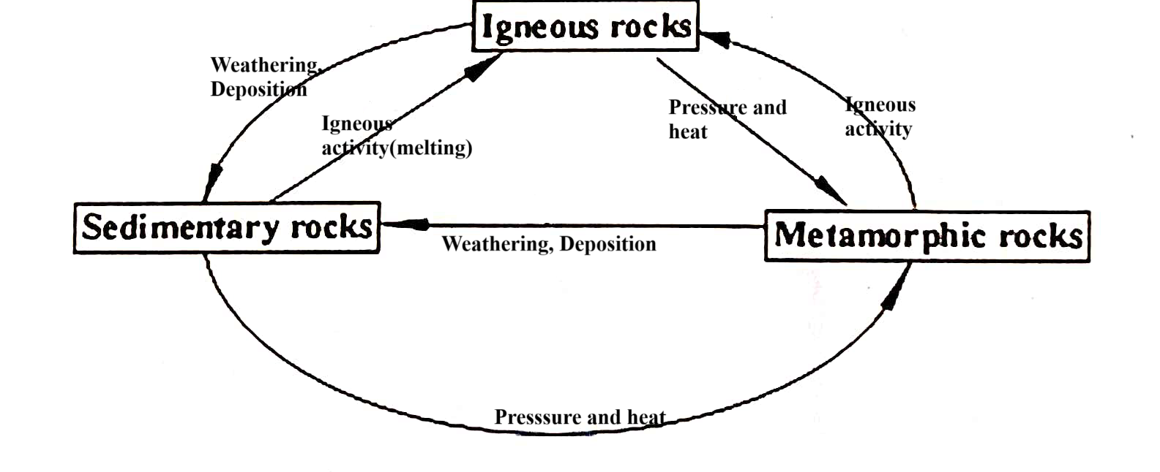
(Correct diagram 4 marks)
(ii) -They have steep slopes which cause the warm moist air to quickly rise along the leaching edge
-They break down into fertile soils.
-They are used in the production of cement.
-They are used for decoration on jewellery and buildings.
-They are sources of valuable minerals
-They act as water reservoir through aquifer.
-They provide salts for both domestic and industrial purposes.
-Clay is used in brick making and pottery
-Rocks are a source of fuel such as coal and oil.
(Any 3 points, 3 marks)

d. -Rain is liquid water that falls from cumulonimbus and nimbostratus clouds while hail is rain drops that
have frozen in the sky and fall to the ground. (2marks)

SECTION B (25 marks)
4. a. (i) | -Cactus (1 mark)
(ii) | -Hot desert climate (1 mark)
(iii) | -Long roots absorb water at great depth (1 mark)
- Very thick leaves and stems in order to store water
- Produce sleepy seeds that lie dormant when it is dry and germinate when
water is available
- Thick waxy cuticle in order to prevent transpiration (any three points for 2 marks each)
(iv) | - Droughts
 | - Poor sandy soils
 | - High evaporation rates
(Any two points, 2 marks)

b. (i) 1 mark for each isobar
    - 2 marks for correct arrow showing direction of wind
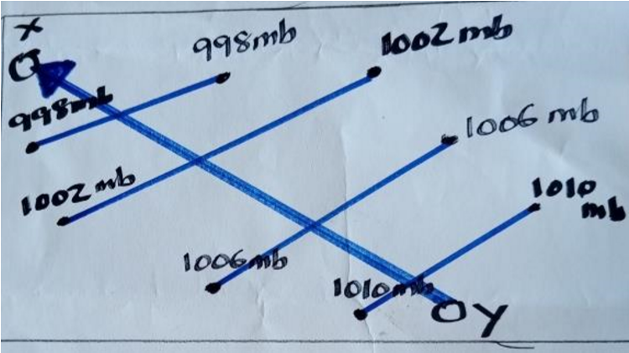
    - Wind blows from a region of high pressure ⁽¹⁾ to a region of low pressure. ⁽¹⁾
(2 marks)

c. (i) -It is an extremely large body of air whose properties of temperature and moisture content at any given altitude are fairly similar in any horizontal direction.
(1 mark)
(ii) - latitude
- source
(two points 1 mark each)
d. -It is found within the tropics
-It influences high temperature
-It is a zone of low pressure
-It keeps shifting to the northern and southern hemispheres with apparent movement the
sun

5. a. (i) Land breeze
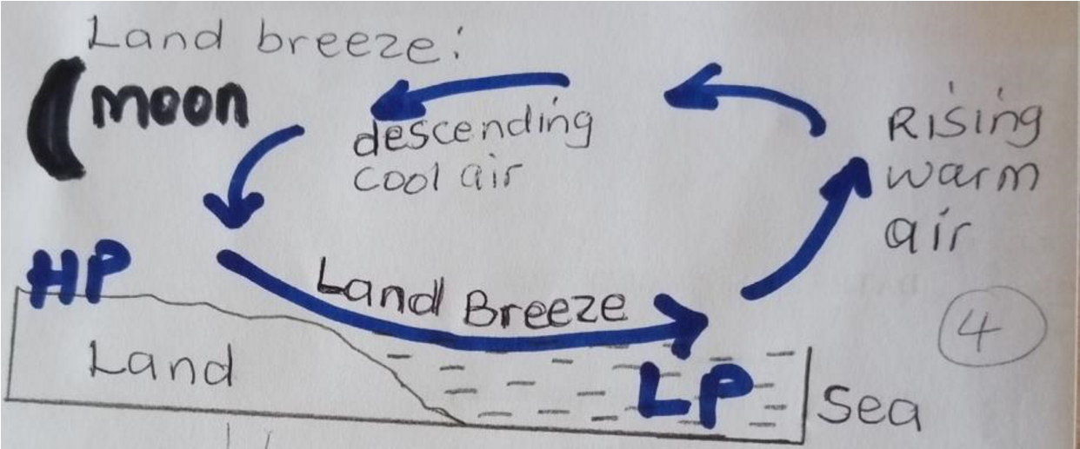
Explanation:
During the night, land cools faster than water.¹ Therefore, cool air blows from the land where there is high pressure¹ to the sea where pressure is low.¹

(ii) - It helps sailors to sail into the sea at night
- It cools sea temperatures and all coastal areas by night
(Any two points, 1 mark each)

(iii) -Air masses from the landmass are dry ⁽¹⁾ while those from the oceans are moist. ⁽¹⁾ (2 marks)

b. (i) B = Sub tropical high / Horse latitude pressure belt (1 mark)
C = Temperate low-pressure belt (1 mark)

(ii) -Intense heating due to the overhead sun leads to expansion and rising of air, creating intense low-pressure cells called the doldrums
-Air thrown from the 30ºN and 30ºS high pressure belts towards the equator comes to occupy a
larger space. It spreads out, and its weight per unit area decreases hence low atmospheric
pressure.
-The region is characterized by the meeting of warm moist winds (trades winds) which mix up
and rise into the atmosphere, creating the intense low pressure cells
(4 marks, 2 for any one point)
(iii)-They are warm winds
-They blow from an easterly direction
-They blow from Horse Latitudes to the doldrums (3marks)

c. (i) Environmental issues refers to harmful aspects of human activities on the biophysical environment
while environmental problems refers to difficulties that are caused by human activities as a result in
changes in the environment. (2marks)

(ii) -pollution
-drought
-flooding
-desertification
-acidic rain (3marks)

END OF MARKING KEY

